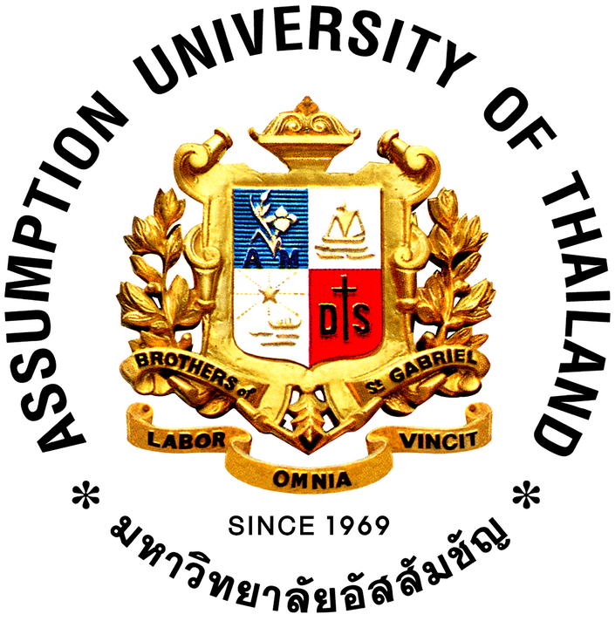

**STUDENT EXCHANGE FACT SHEET 2021-2022**

|  |  |
| --- | --- |
| **Contact Information** | |
| **Name of University** | Assumption University of Thailand  The Office of International Affairs |
| **Address, Telephone & Fax** | **Huamak Campus**: Ramkhamhaeng 24 Rd., Hua Mak, Bangkok 10240  **Tel:** (66) 0-2300-4543-62 **Fax.** (66) 0-27190482 E-mail: **gchatelier@au.edu** |
| **The Office of International Affairs Address, Telephone & Fax** | Assumption University of Thailand  The Office of International Affairs "L" Building Ground Floor 592 Ramkhamhaeng 24 Road Huamak, Bangkok 10240 Thailand  **Tel:** 66(0) 2 300-4553 ext.3728-9 **Fax:** 66(0) 27190482 |
| **Contact Persons, title and email address** | Director: **Mr. Glen Chatelier** E-mail: **gchatelier@au.edu** |
| Manager: **Mr. Glen Chatelier** |
| Incoming Student Coordinator: **Mr. Thanathip Singhakul** Email: **thanathipsng@au.edu** |
| Outgoing Student Coordinator: **Mr. Thanathip Singhakul** |
| **Contacts, if exchange administered by specific faculty** | Faculty contacts: **Mr. Glen Chatelier**  Incoming: **Mr. Glen Chatelier**  Outgoing: **Mr.** **Kyoichi Yokota sensei (Japanese)** Email: [kyoichi_yokota@hotmail.com](mailto:kyoichi_yokota@hotmail.com)  **Ms. Siriwan Preechanarit sensei** Email: [angchan43@hotmail.com](mailto:angchan43@hotmail.com) |
| **Website** | University Website : www.au.edu  Student exchange related website : www.oia.au.edu |

|  |  |
| --- | --- |
| **Academic & Course Related Information** | |
| **Academic Calendar** | **_ 1st__ Semester**: (June – October 2022) Application Deadline : March 9, 2022  Arrival and Orientation  Orientation: 1 week after semester begins  Course Registration Period: Jun 2 , 2022 (Tentative)  Exam: Mid: **August , 2022** Final: **October, 2022**  Program end date: *Oct , 2021*  **__2nd__ Semester**: (November2022 – March 2023) Application Deadline : August 9, 2022  Arrival and Orientation Dates:  Orientation : *To be announced*  Course Registration Period : November 3, 2022 (Tentative)  Exam : Mid: **January, 2023** Final: **March, 2023**  Program end date: **March , 2023** |
| **Course information** | Website: <http://www.au.edu/index.php/study-programs/undergraduate-programs>  (Please attach any course-related materials by file)  English courses: All  **Course Mandatory Requirements:**   1. At least 80% class attendance   (Less than 80% attendance warrants Final Examination debarments)   1. Quizzes (Some may be scheduled on Saturdays) 2. Assignments / Projects / Presentations. 3. Mid-Term Examination 4. Final Examination   (Missing or not fulfilling any of the requirements above will result Grade “F” on the course)  Courses in other languages: *(please refer to the University website)* |
| **Course Restrictions** | Course Pre-Requisites as specified in Bulletin  <https://admissions.au.edu/wp-content/uploads/2020/10/Bulletin-2020-2021-Assumption-University.pdf> |
| **Minimum & Maximum Credits per Semester** | 15 Credits |
| **Grading System** | As in bulletin |

|  |  |
| --- | --- |
| **Admission** | |
| **Application Deadline(s) for Admission** | __1st__ Semester : March 9, 2022  __2nd__ Semester : August 9, 2022 |
| **The number of Exchange Credits Required** | Undergraduate : one-semester units: 15 one-year units: 30 |
| **Application Requirements** | Minimum GPA Requirement : 2.5  Acceptable Language Test & Minimum Language Requirement : IELTS 6.5  TOEFL ITP submission : 500  Other Requirements : - |
| **Documents Required to be Submitted** | Application form (web link or electronic file) :  <http://www.oia.au.edu/au-international-profile/inbound-student.html>  Other Supporting documents : As stated in application |
| **Compulsory fees for International students** | (Insurance, activity fees, etc.) - Insurance |
| **Language courses for exchange students** | (Please give any information on free, fee-based or subsidized language courses for exchange students) : - Basic Thai Language : 22 Hours |

|  |  |
| --- | --- |
| **Housing/Accommodation and Arrival Information** | |
| **Accommodation (Dormitory) Arrangement Guaranteed?** | Yes or No NO |
| **Types and fees** | On campus :  Off campus : Only |
| **On campus dormitory & housing** | Cost : 4,000 Baht (shared room/ not include electricity and water expenses):  Period available :  Number of occupants per room : 2  Application form (web link or electronic file) : <https://www.au.edu/about-au/housing-dining.html>  Housing application deadline : - Contact Person : Dr. Samusa Nagasingh Email: intercenter@au.edu |
| **Off campus housing** | (Will exchange office offer assistance and in what form?)  **Referral system** |
| **Airport arrival pick-up service** | Yes or No NO  Deadline for Submission of Arrival Form : - |
| **Other requirements for housing** | (Such as Vaccination Requirements)  **Recommended Vaccination :** Against tropical diseases |

|  |  |
| --- | --- |
| **Insurance and Visa Information** | |
| **What kind of insurance do students enter?** | Compulsory insurance: YES  Optional insurance:  Exemptions if enter from home country: |
| **Do students need a study visa?** | For one-semester students: YES  For one-year students: YES |
| **How do students obtain a visa?** | Thai Embassy / Consulate |

|  |  |
| --- | --- |
| **Miscellaneous** | |
| **University outline, student body, strengths** | [www.au.edu](http://www.au.edu) |
| **Information on the local area, sights and attractions** | [www.au.edu](http://www.au.edu)  <http://www.oia.au.edu/> |
| **Scholarship Opportunities** | * None |
| **Other** | - |

|  |  |
| --- | --- |
| **Last Update of this information** | 2021 - Nov - 24 |