**Application Procedures for Exchange Students**

Website：<https://jiangnan.17gz.org/apply/index.do>

Step1：Register

Step 2: Please choose “Exchange Student”

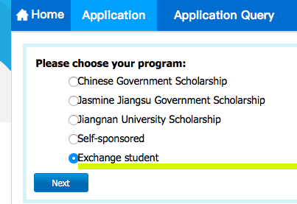

Step 3: Please choose “General Visiting Scholar”

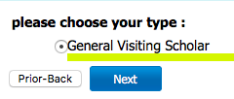

**Step 4: Department and Major**

For Chinese Language Learning Students:

Department: School of International Education

Major: Modern Chinese

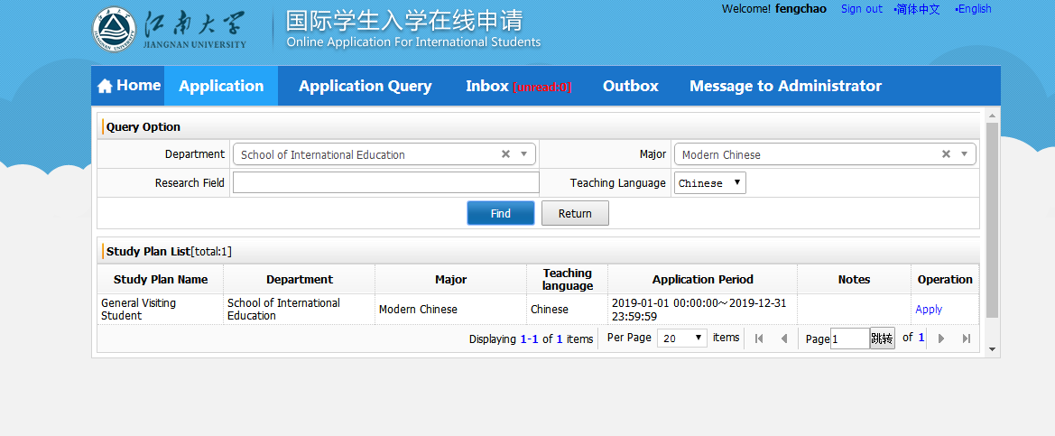

Step5: Fill in all required information

Step6: Document List

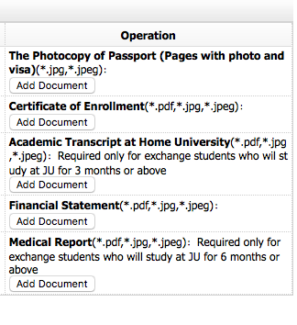

**Notes:**

1. Highest Level of Education: Senior High ( If you are undergraduate now)
2. Photo: full face with white background

Example: 

1. Medical Report: for one semester study, it is not necessary
2. Financial Statement: Use the Template.